## Create the Next Road using Layers

1. Go to **View** from the status tool bar and tick the check box next to Layers List. The Layers Palette will now be visible beneath the Properties palette. Add a new layer and name it Bridge as shown.

* 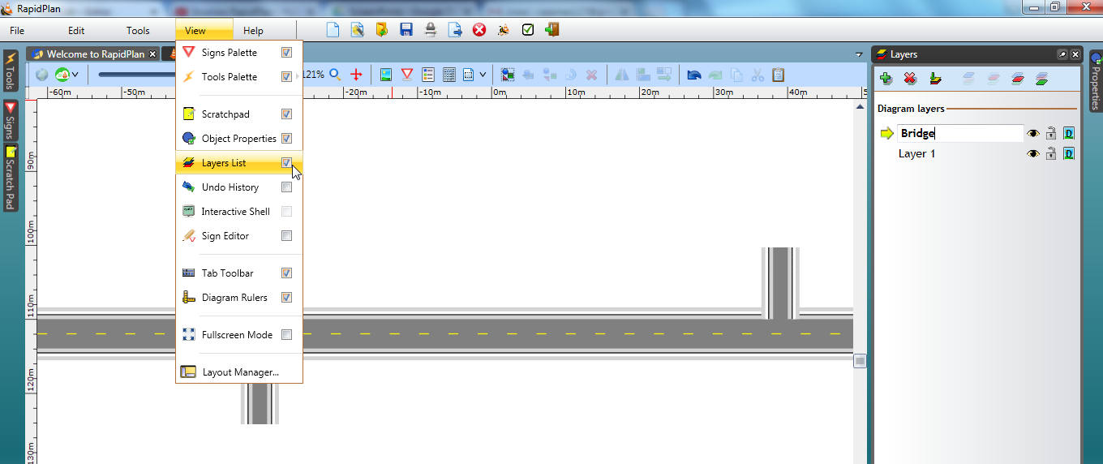
* Overpasses_and_Underpasses_step_3

1. Now stay on the **Bridge** layer and draw a 2-lane road that runs north south between the extended roads drawn in step 2.
2. Add two roads, convert them to single lanes and add 1 control point half way along each of the new side roads as shown.

* 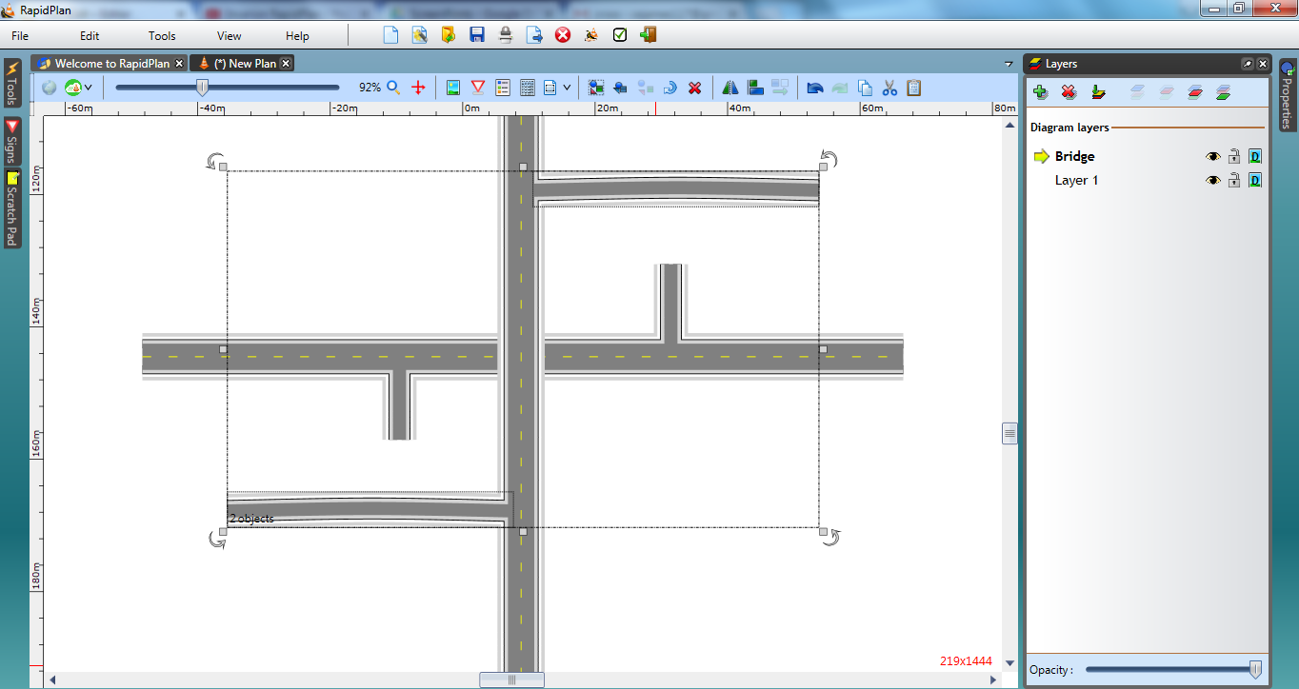
* Overpasses_and_Underpasses_steps_4_and_5

1. Using the two control points on the side roads, shape them both down until they meet neatly with the side entrances to the east-west road. We have left a gap in the top one so that you can see how we have done it.

* 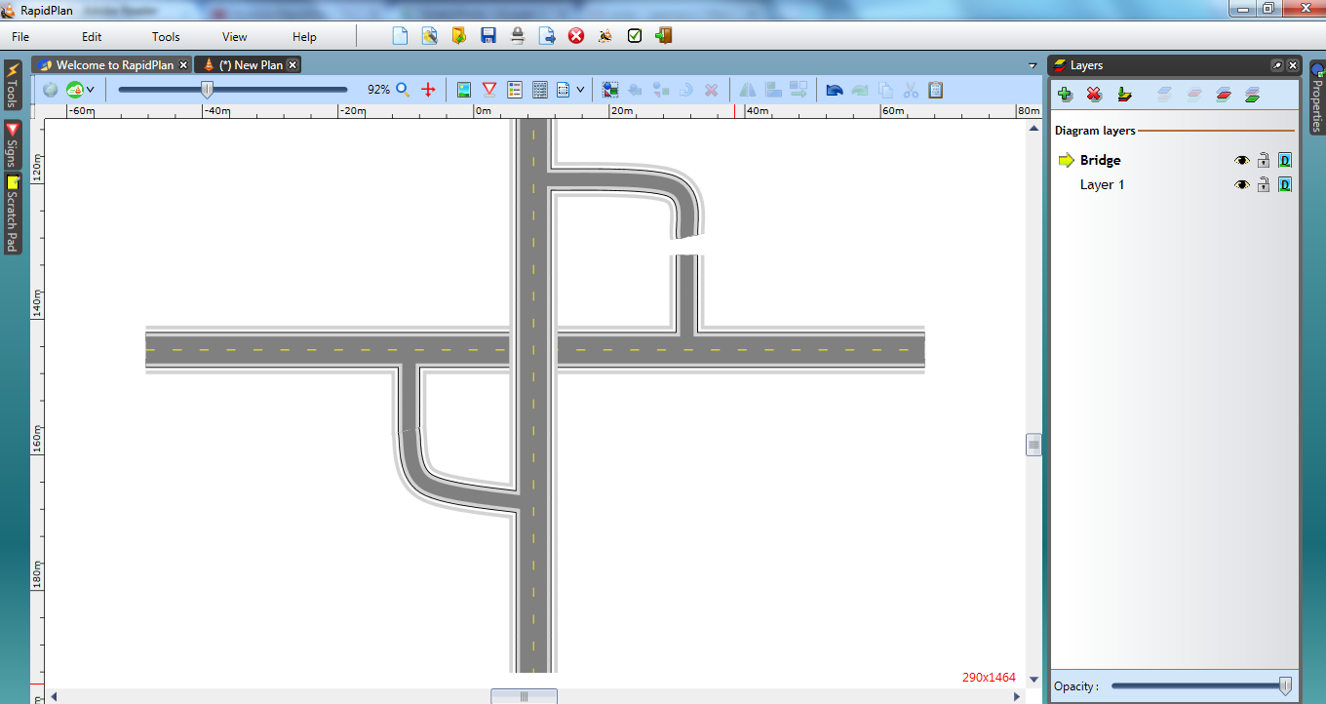
* Overpasses_and_Underpasses_step_6

1. Double click the bridge road and change the lane markings to double.